**WebSocket:**

WebSocket is a HTTP computer communications protocol, providing full-duplex communication channels over a single TCP connection. It has useful application of making the web application interactive.

For example – social feeds, news feeds, game score update, chat, financial, tickets, collaborating apps (google doc) etc.

* It uses port 80/443 (URL scheme ws:// or wss://)
* It has small over head for text messages (frames)

**STOMP**: Formerly known as TTMP, it is a simple text-oriented text messaging protocol. It helps us with basic protocols like connect, send, subscribe etc.

This is a sub-protocol. STOMP is needed because unlike HTTP, web socket doesn’t define any protocol. So, the web socket connection doesn’t have the header, payload etc. like HTTP. It is just some bytes passed to TCP (network layer). STOMP helps us with solving this exact problem.

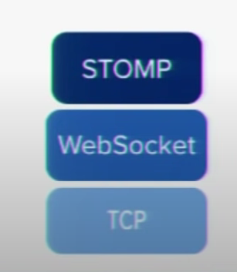

**Web Socket clients:** The browser isn’t the only supported client, we can use mobile client or server to server communication.

To configure web socket in spring boot application we can use the following format:

